TM032

Rachael Valdez

November 10, 2017

### Test Method

This test method analysis will be used to determine if fast protein liquid chromatography(FPLC) and tangential flow filtration(TFF) meet the set specifications for each run to be built into production.Several samples throughout the downstream processing will be tested to make sure the protein is still functional and loss during processing is minimized. The protein is tested for activity at 8% against 4 positive and 1 negative bacterial strains to make sure the protein is targeting set organisms. Using a Spectramax-L, luminescence is measured over 12.5 seconds. The data generated is from a Spectramax-L which outputs a .txt file which will be imported.

### Data Analysis

1: Import data and libraries

2: Calculated averages

3: Calculated standard deviation

4: Calculated CV

5: Generate strain analysis chart with pass or fail

6: Generate dot plot

7: Generate bar graph

8: Data export

Note: Before running script go to section 8 and input a unique name identifier so files do not save over each other.

### 1: Data Import

Data file, .txt, will be imported. The columns will be named and the peak of each well will be calculated.

## Loading required package: rJava

## Loading required package: xlsxjars

### Strain Analysis

Each bacterial strain tested will have the average, standard deviation and CV calculated. Based off of these calulations a chart will be output with the set specifications and a pass or fail output.

### 2: Peak Value

## Strain1 Strain2 Strain3 Strain4 Strain5 Strain6  
## AVC 32598 8293 19544 2614 230 101  
## Retentate 21306 10238 11746 1862 165 109  
## Eluate 31508 9314 22744 3360 109 181  
## Lysate 59816 8558 4036 2171 246 101  
## LM 32812 10445 4185 1442 327 291  
## FT 259 236 246 264 245 264  
## Wash1 264 282 214 232 245 218  
## Wash2 8966 6137 3130 473 264 273

### 3: Standard Deviation

## Strain1 Strain2 Strain3 Strain4  
## AVC 9359 148 2030 221  
## Retentate 142 967 1075 353  
## Eluate 335 194 858 415  
## Lysate 3287 114 518 85  
## LM 3050 373 296 341  
## FT 96 13 39 77  
## Wash1 13 64 6 6  
## Wash2 829 419 116 116

### 4: Coefficient of Variation

## Strain1 Strain2 Strain3 Strain4  
## AVC 28.71 1.78 10.39 8.45  
## Retentate 0.67 9.45 9.15 18.96  
## Eluate 1.06 2.08 3.77 12.35  
## Lysate 5.50 1.33 12.83 3.92  
## LM 9.30 3.57 7.07 23.65  
## FT 37.07 5.51 15.85 29.17  
## Wash1 4.92 22.70 2.80 2.59  
## Wash2 9.25 6.83 3.71 24.52

### 5: Strain Specification

Each positive control will have a pass or fail based on set specification output. If one strain does not pass, the test method failed.

## Retentate TMSpec  
## Strain1 0.906147668949926 Pass  
## Strain2 1.0197953900295 Pass  
## Strain3 1.12865921324774 Pass  
## Strain4 0.980015899031606 Pass

### 6:Dot plot

Plot showing RLU distribution for each strain

## No id variables; using all as measure variables

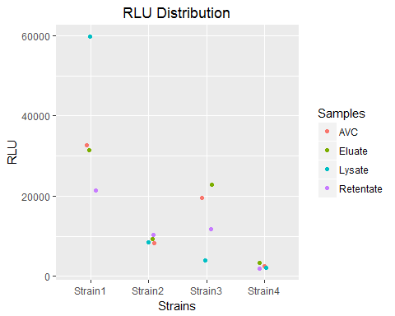

### 7: % Recovery graph

Graph showing distribution of % recovery for each strain and sample calculation output for each sample.

## Strain1 Strain2 Strain3 Strain4  
## FT 1 6 12 24  
## Wash1 0 1 2 5  
## Wash2 13 65 70 20  
## Eluate 24 49 254 70  
## Sum 38 121 338 119

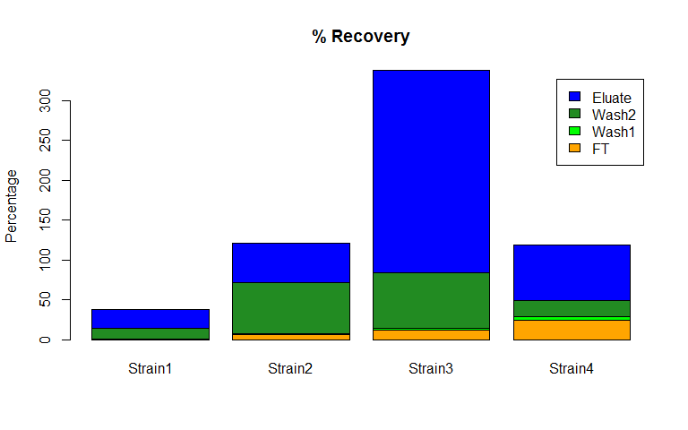

### 8: Data Export

Create a unique name identifier for saving files each time script is run. Example:"../Data/Plate1_PeakValues.xlsx"

write.xlsx(PeakValues, "../data/Plate2_PeakValues.xlsx") #Export max values of plate  
write.xlsx(Mean, "../data/Plate2_Mean.xlsx") #Export Mean values of plate  
write.xlsx(SD, "../data/Plate2_SD.xlsx") #Export StDev values of plate  
write.xlsx(CV, "../data/Plate2_CV.xlsx") #Export CV values of plate  
write.xlsx(TMResults, "../data/Plate2_TMResults.xlsx") #Export TMResults values of plate